**Cue combination Decision Making Model**

In a recent paper (Drugowitsch et al. 2014) proposed a diffusion model for the combination of visual and vestibular cues for self-motion heading across time and sensory modality. The model describes how information is accumulated until it reaches a decision boundary (θ) and participants would make a speeded response. The model takes the motion profiles of the stimulus into account (1A-C).

 (1A)

 (1B)

 (1C)

The diffusion model for the visual condition with the raised cosine velocity profile (Eqn. 2A), the visual condition with the constant velocity profile (Eqn. 2B) and the vestibular condition with the acceleration profile (Eqn. 2C) are given by

 (2A)

 (2B)

 (2C)

*Where k* is a positive constant relating particle drift to heading angle (Angle), and η(*t*) is Gaussian white noise. We make the assuming that the visual and vestibular conditions have equal drift constants, as the reliability of the response are proportional to the reliability of the cue

 (3)

To account for the sensory input which modulates the cues reliability, the diffusion model is modified for the vestibular and visual conditions by the motion acceleration *a*(*t*) and motion velocity *v*(*t*), respectively. The new diffusion models are given by

 (4A)

 (4B)

 (4C)

The weighted combination of the drift diffusion model is given

 (5A)

 (5B)

where

. (6)

The sensitivity profile for the combined condition d(t) is a weighted combination of the unisensory profiles

 (7A)

 (7B)

The modified combined diffusion model takes into account of the sensitivity profile

 (8A)

 (8B)

Figure 1 depicts the numerical solution of the diffusion model for the vestibular condition (left column Eqn. 4C), the visual condition (middle column Eqns. 4A, 4B) and the combined condition (right column Eqns. 8A, 8B). As mentioned we cannot fit this model to our data as in participants did not perform a speed response for this reason the decision boundary (black dashed line) for the different conditions are qualitative.

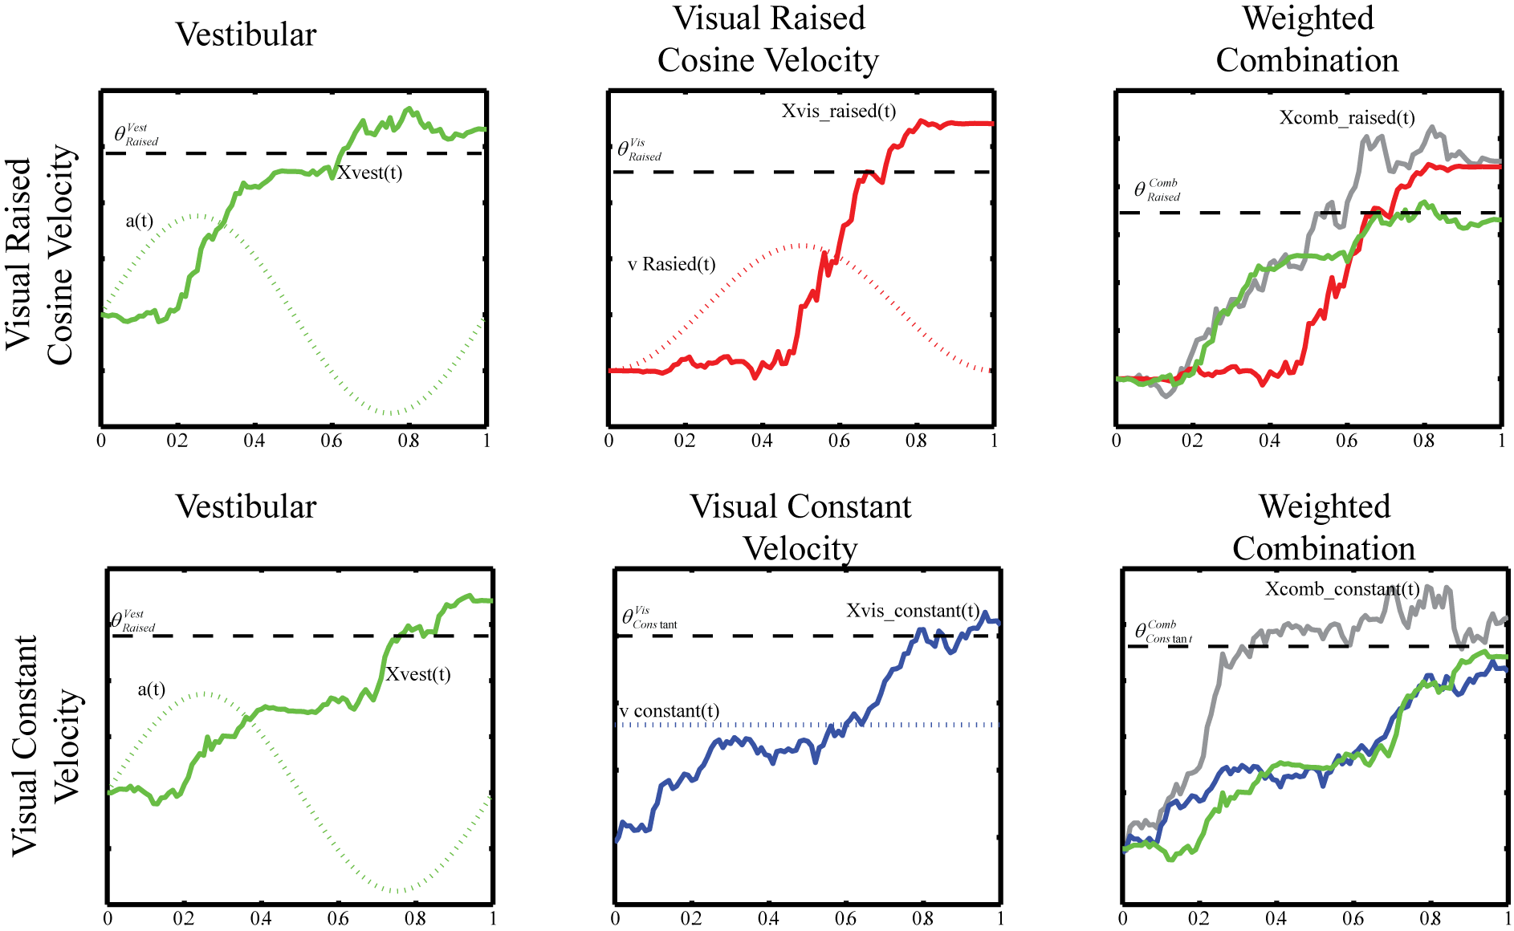

Figure 1 Representation of the diffusion model (solid line) and motion profile (dotted) for the vestibular (left column), visual (middle column) and combined (right column) for the visual condition with constant velocity motion profile (top row) and the raised cosine motion profile (bottom row). The dashed line is the decision boundary.

The data in Figure 1 illustrates how the unisensory cues do not have to accumulate information at the same rate for them to be combined in an optimal fashion, this could explain why we see optimal combination of visual and vestibular cues even when the motion profiles are incongruent.

Drugowitsch J, DeAngelis GC, Klier EM, Angelaki DE, Pouget A (2014) Optimal multisensory decision-making in a reaction-time task. Elife:e03005 doi: 10.7554/eLife.03005